SurveyOn

Take Survey

Website User Manual

**Contents**

Introduction 3

The Admin has the functions of approving or disapproving the questions reported by the user. The admin can also view all the login details. 3

Users of the system 3

User Requirements 3

User Homepage 4

About Us 5

How it Works 5

Login 6

Surveys 7

Respond 7

Recommend 8

Contact Us 8

Admin 9

Reported History 9

# **Introduction**

SurveyOn is a web application for users to take surveys for various categories that are being conducted all over the world. A new user must sign up to the web application to view the various surveys that are taking place and respond to those surveys they are interested in. Our target market is for any customer -who want to rate the product they are using. This would help a new user who wanted to buy it and who are planning to purchase. We cannot view the surveys until the user is logged in. This means that a new user will be redirected to the sign-up page and the returning user will be redirected to the login page. Once the signup/login is completed, a user can view the surveys and their details and proceed to respond. It must be noted that whenever a user respond the Rewards would increase. Person with highest rewards are active users. On successful participation, reward would increase. Also, user can report a question if felt inappropriate. Appropriate messages will be displayed to the user when the survey is responded.

# The Admin has the functions of approving or disapproving the questions reported by the user. The admin can also view all the login details.

# **Users of the system**

a. Admin

The Admin of the system is the one managing all the reports. Admin can approve or reject

b. Customer

Customers are users from all over the world. Each user need to have login credentials to view or post the survey. Once they have the credentials they can view and respond to multiple credentials

# **User Requirements**

a. Admin

The Admin can be a technical person. But the User Interface for the Admin is developed in such a way that any non-technical person can easily handle. Admin has two functionalities namely Approve or reject. Simple Buttons have been created for these and user can simply click on those buttons and perform the functions. In case of a DB Admin, we have two tables in the database that are linked to each other. To add new admins, the DB Admin will have to change the “Type” of the user from Participant to Admin.

b. Customer

Customers are students, young and old people. A simple User Interface is created that view the survey, respond to the survey. Add survey to create new survey. The customer is free to create multiple surveys and respond to multiple surveys. User would get some rewards for the participation and posting the surveys.Type of the user is Participate.

# **User Homepage**

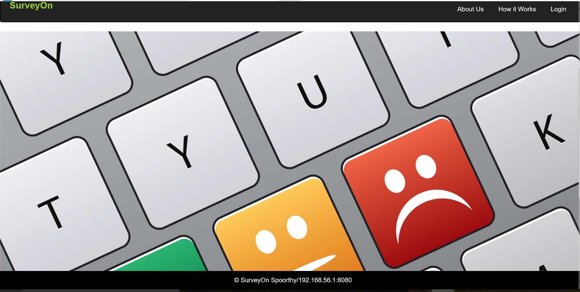

This is the home page for a user. The header includes navigation to other pages. Clicking on the Login button will go the Login/Sign up form. Clicking on the About Us Page will display info regarding the website. How it works give key info on working nature of the website

# **About Us**

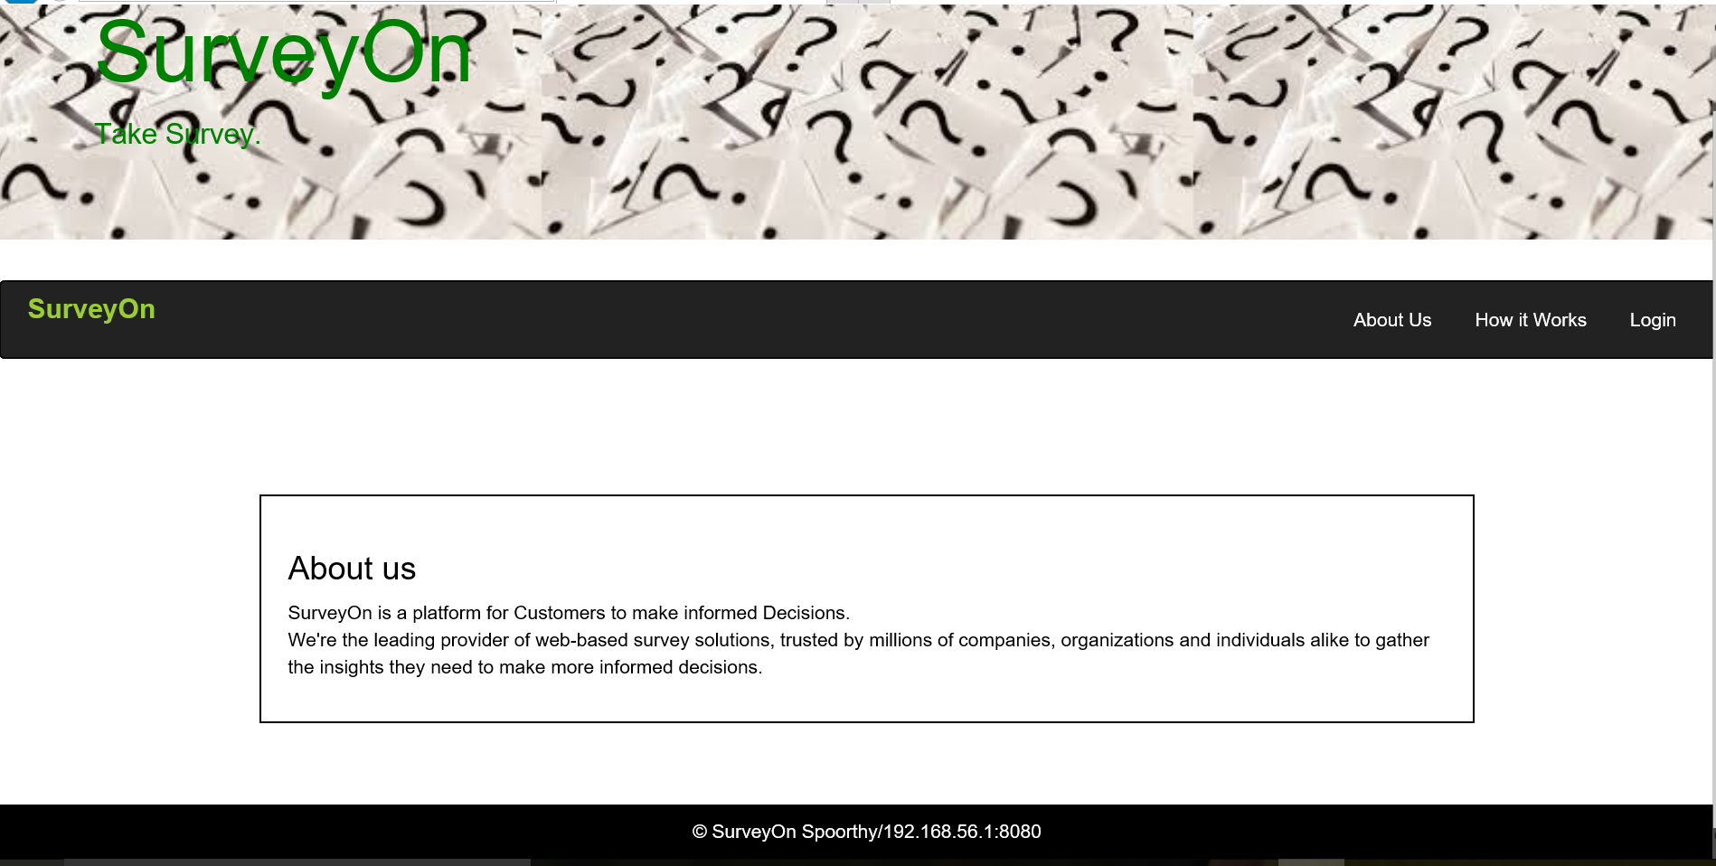

Clicking the About Us link in the header gives the About Us Page that contains information about the company.

# **How it Works**

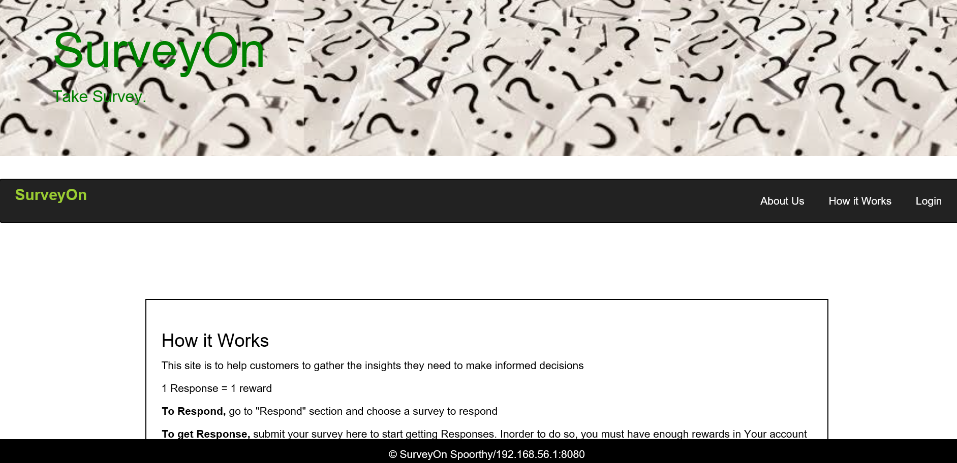

Gives information about how the company works.

# **Login**

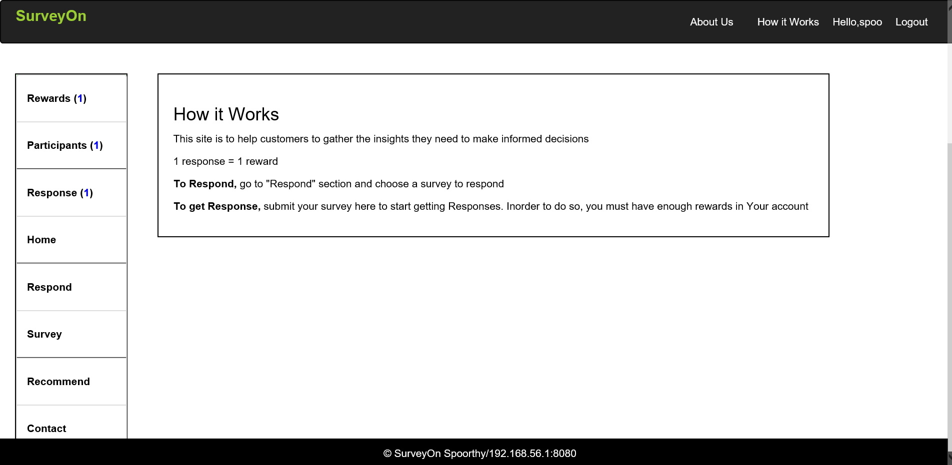

Page once the user logs in

# **Surveys**

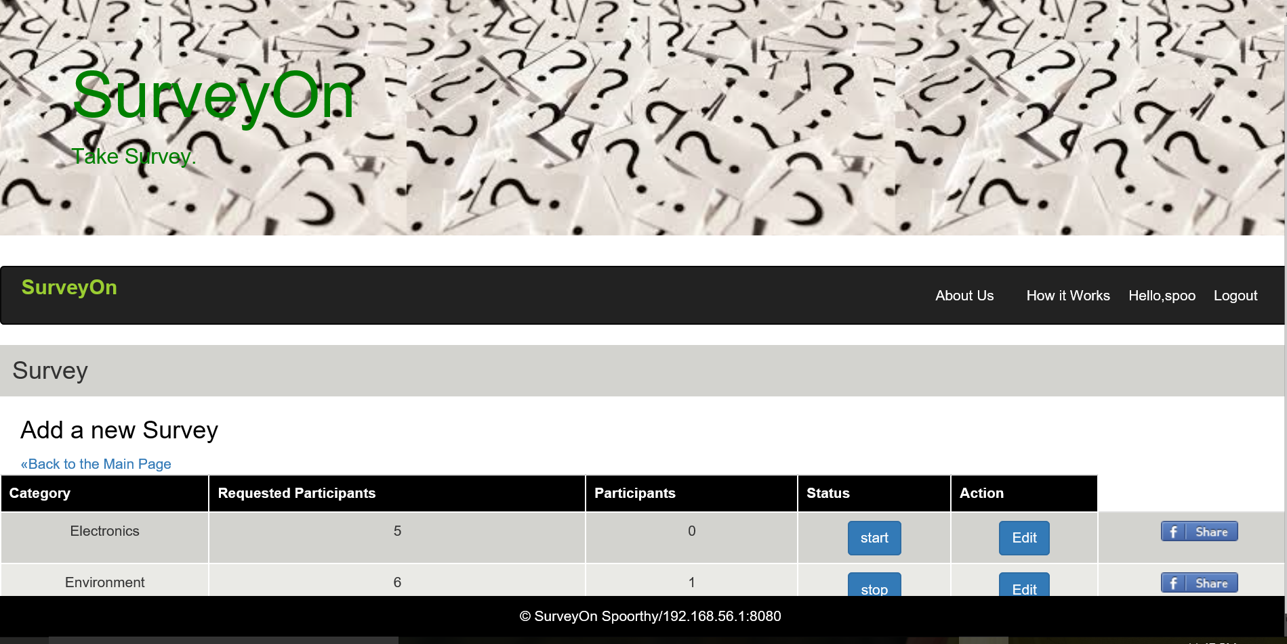

View of surveys

# **Respond**

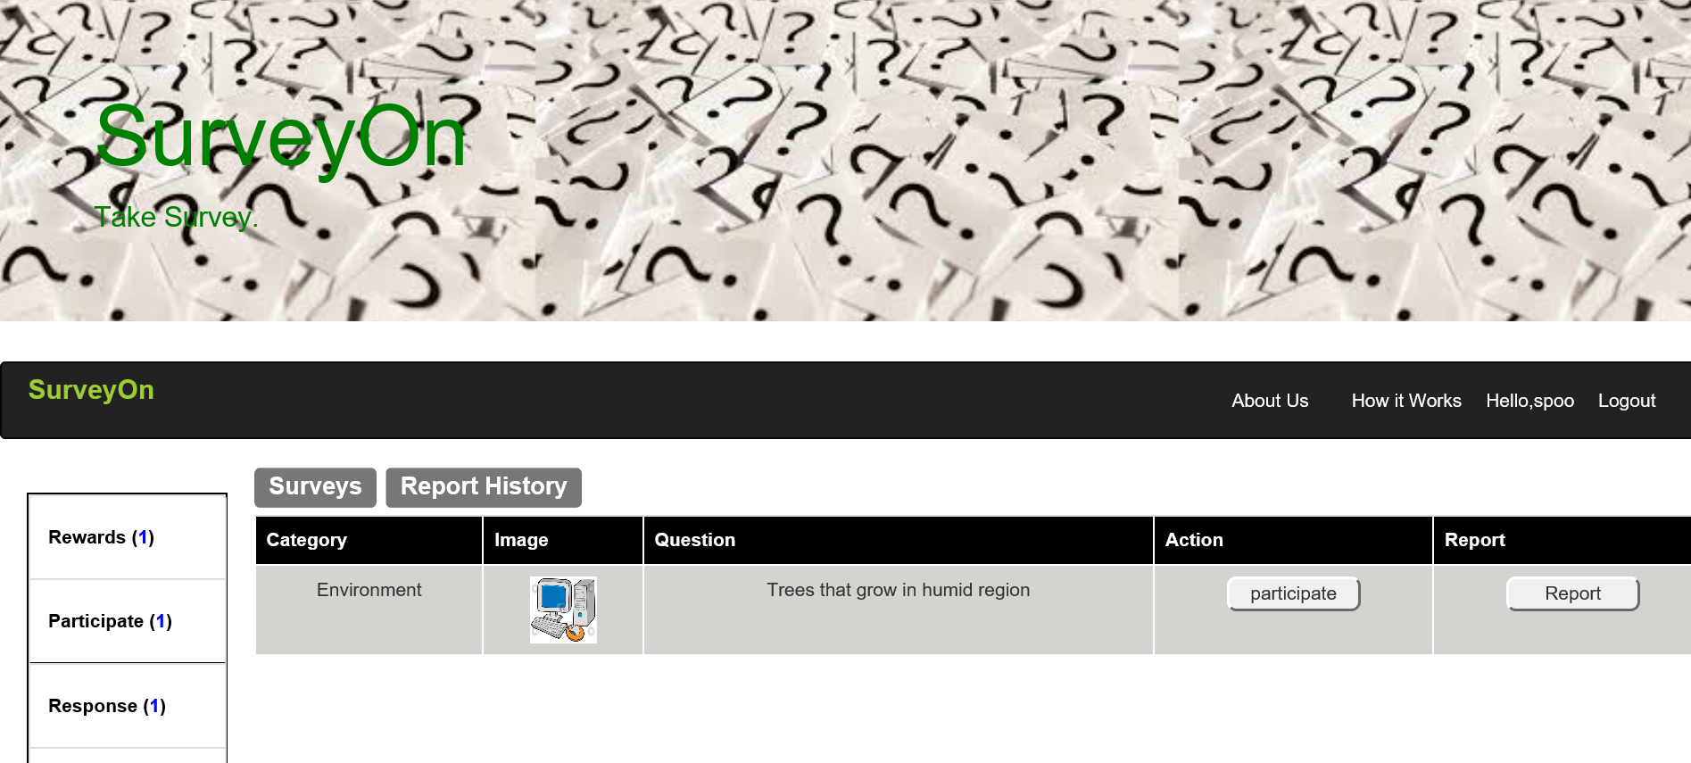

Respond page

# **Recommend**

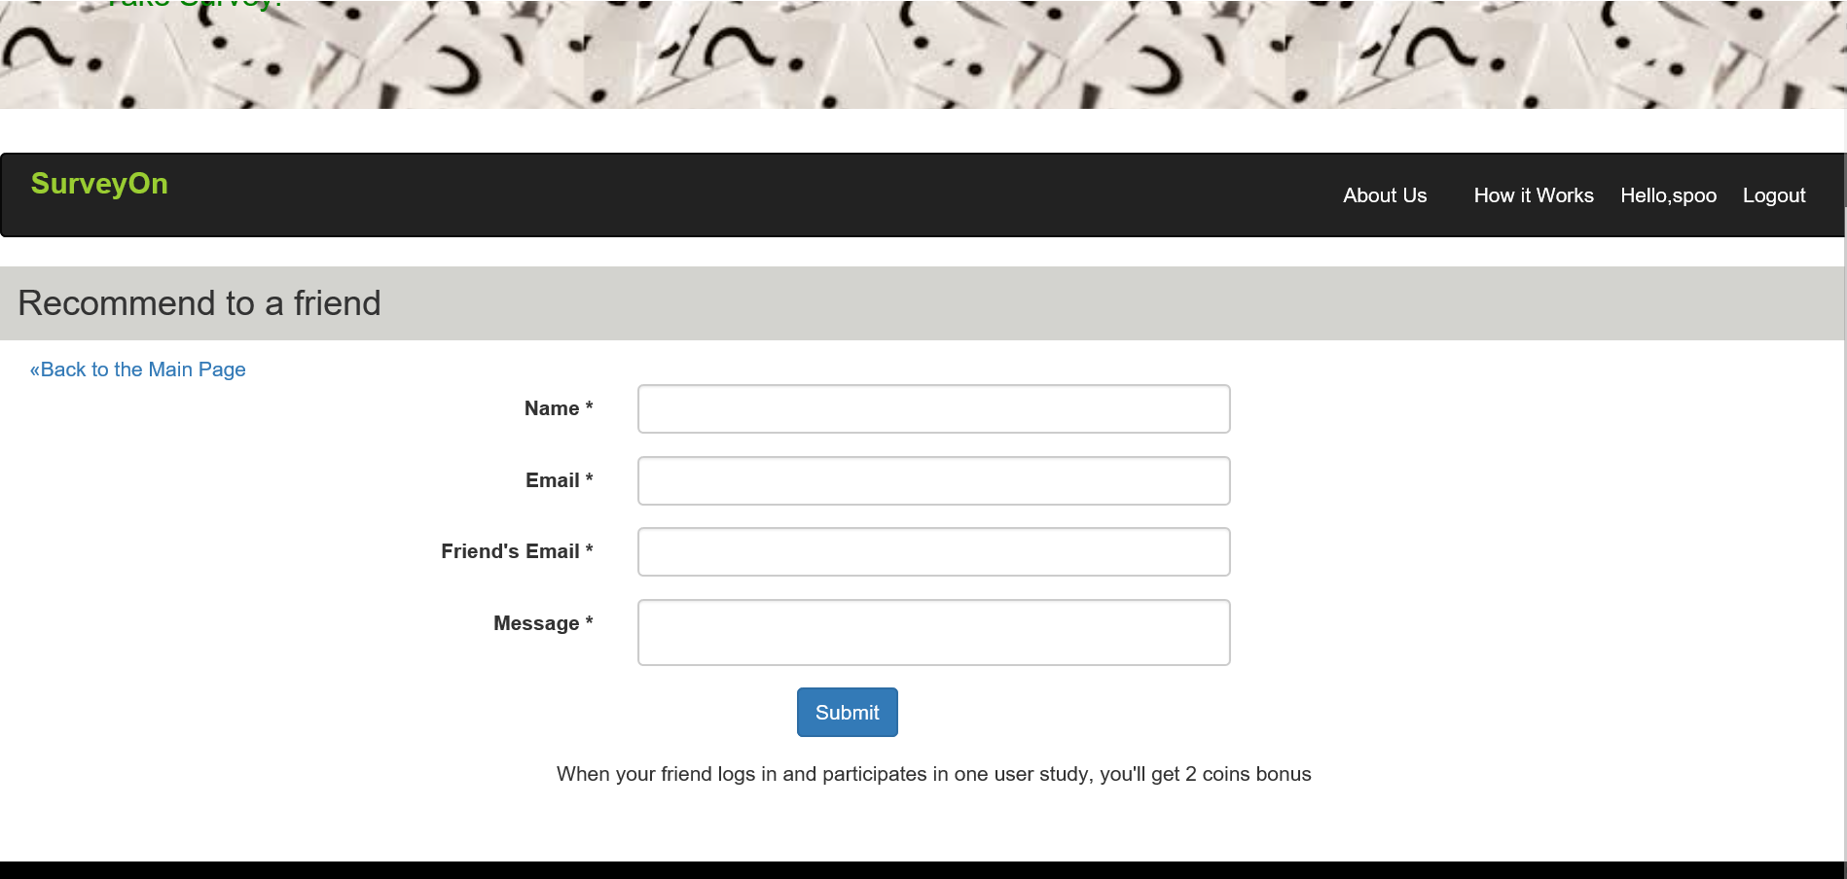

Mail will be sent to the email

# **Contact Us**

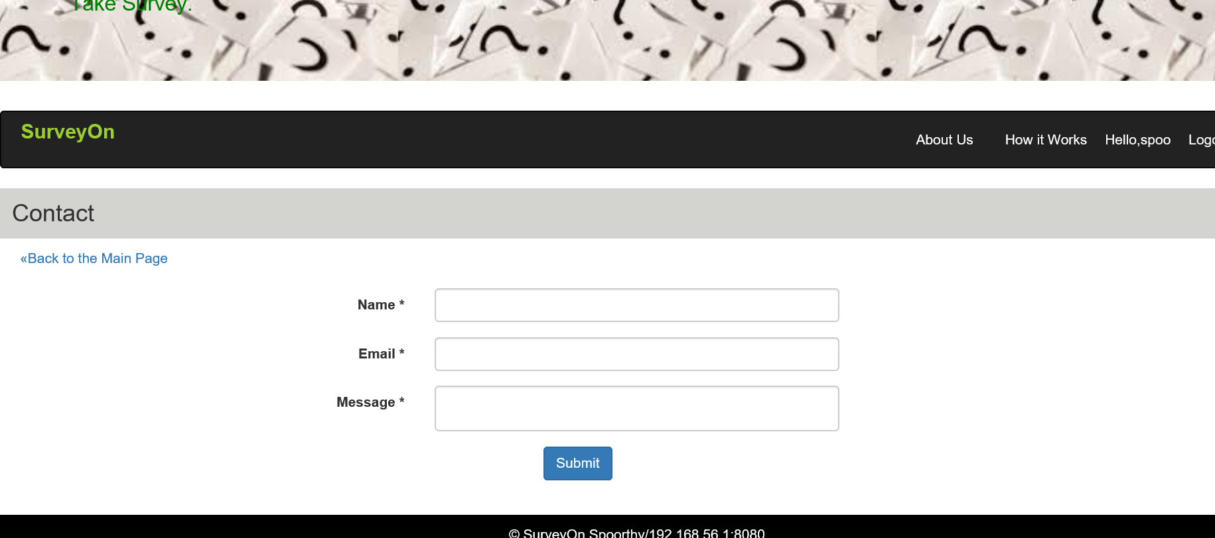

# **Admin**

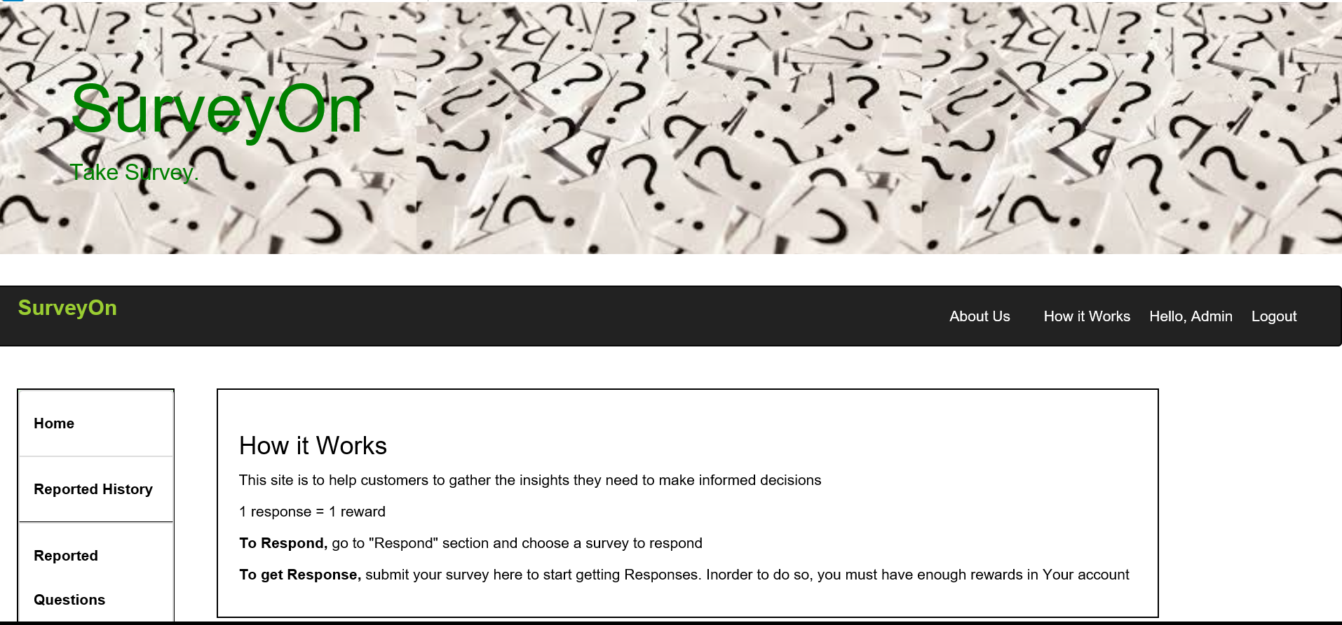

Home page for admin Login

# **Reported History**

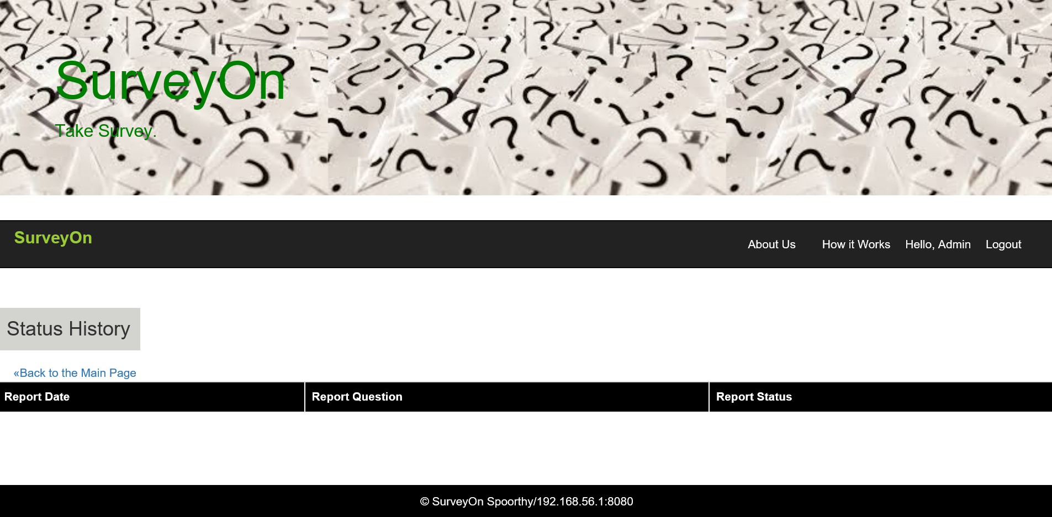

Reported history would be viewed here